TECHNO MACHINE TOOLS

Survey no:126/A/1, DOOR NO: 4-132-9/A/2, Gandimaisamma X Road,

Medchal Malkajgeri, Hyderabad-500044.

(Machine tool manufacturers)

T.SIVARAMAKRISHNA
ME., MBA.
--------------------------------------------------------------------------------------------------------------------------------------

TMT/ Ravinder Naik/S0380/2025 12-07-2025

To,
Ravinder Naik,
Mobile: +91 98582 36666

Dear Sir,

Sub: - SUPPLY OF ROOFING PROFILE ROLL FORMING MACHINE

With reference to our telephonic conversation regarding your requirement of roll forming machine mainly for Color Coated Roofing Section. We are glad to inform you that we would be in a position to supply you the required equipment. Given below are the required specifications and description of the machine and our terms and conditions.

Prices

The cost of Roll forming machine with roofing profile tooling along with Entry guide, Main Roll Forming Machine, Side Guides, Drive System, Cutting Unit and Cutting Die Sets for Rs 43,50,000/- ( Rupees Seventy Three Lakhs Fifty Thousand Only)

LIST OT EQUIPMENT

- HYDRAULIC DE COILER 5 MT CAPACITY WITH 5 HP DRIVE WITH 3 HP POWER PACK
- Coil car 5 ton capacity
- ROLL FORMING MACHINE WITH 24 PASSES
- EN 31 ROOFING PROFILE TOOLING
- 5 KW SERVO DRIVE WITH RUDUCTION GEAR BOX.
- COMPLETE ELECTRICALS ALONG WITH AUTOMATION – PLC
- DELIVERY CUTOFF UNIT WITH 7.5 HP POWERPACK
- AUTO STACKING UNIT WITH 7 METERS
- FILM REEL UNIT
- ENTRY SHEAR
- PRINTING UNIT

TECHNICAL SPECIFICATION:

GENERAL DATA

Productivity : ROLL FORMING CUT TO SIZE PROFILE

Manpower required : ONE OPERATOR TWO ASST. REQUIRED

Total Power Required : 23 HP

Set up time : COIL LOADING 2-3 MIN, SHEET FEEDING 3-4 MIN

Production capacity : 20000 KG PER SHIFT 8 HOURS

Working hours per day : 8-12

Line direction : LEFT TO RIGHT

Overall floor space required : 13 METERS (L) 2 METERS (W) 1.2 METERS (H)

Approx weight : 9000 KG

Line speed : 3-15 MPM

Model No : TM/RF/111

Model Type : CRFM

MATERIAL SPECIFICATIONS

Type of material to be processed : CR/COLOR COATED/GI/AL

uts : 32-42 KG/MM2
% Elongation : 18-25
Shear strength : 40-45 KG/MM2

Maximum width can be processed : 1220 MM

Minimum width can be processed : 1020 MM

Maximum thickness can be processed : 0.6 MM

Mnimum thickness can be processed : 0.36 MM

ENTRY COIL SPECIFICATIONS

Maximum weight of coil : 5 TON

Maximum od of coil at entry : 1600 MM

Minimum od of coil at entry : 600 MM

DE COILER SPECIFICATIONS

Model : SINGLE ARM

Load - capacity : 5000 KG MAX.

width : 1220MM

Mandrel movement : DIA 450 MM - 550 MM

Mandrel Height from ground : 1100 MM

Mandrel expansion : MANUAL

Construction : M. S. FABRICATED.

Mandrel rotation : WITH 5 HP GEARED MOTOR



MILL SPECIFICATIONS

Roll shaft diameter : DIA 70 MM

The vertical distance between shafts : 330 MM

The horizontal distance between shafts : 550 MM

Number of forming stations : 21 NOS

Drive (AC) : 7.5 HP

Delivery shear : 5 HP {power pack)

Speed of the machine : 0-15 meters/max

Shaft material : EN9

Rollers Material : EN31

Hydraulic tank capacity : 300 liters

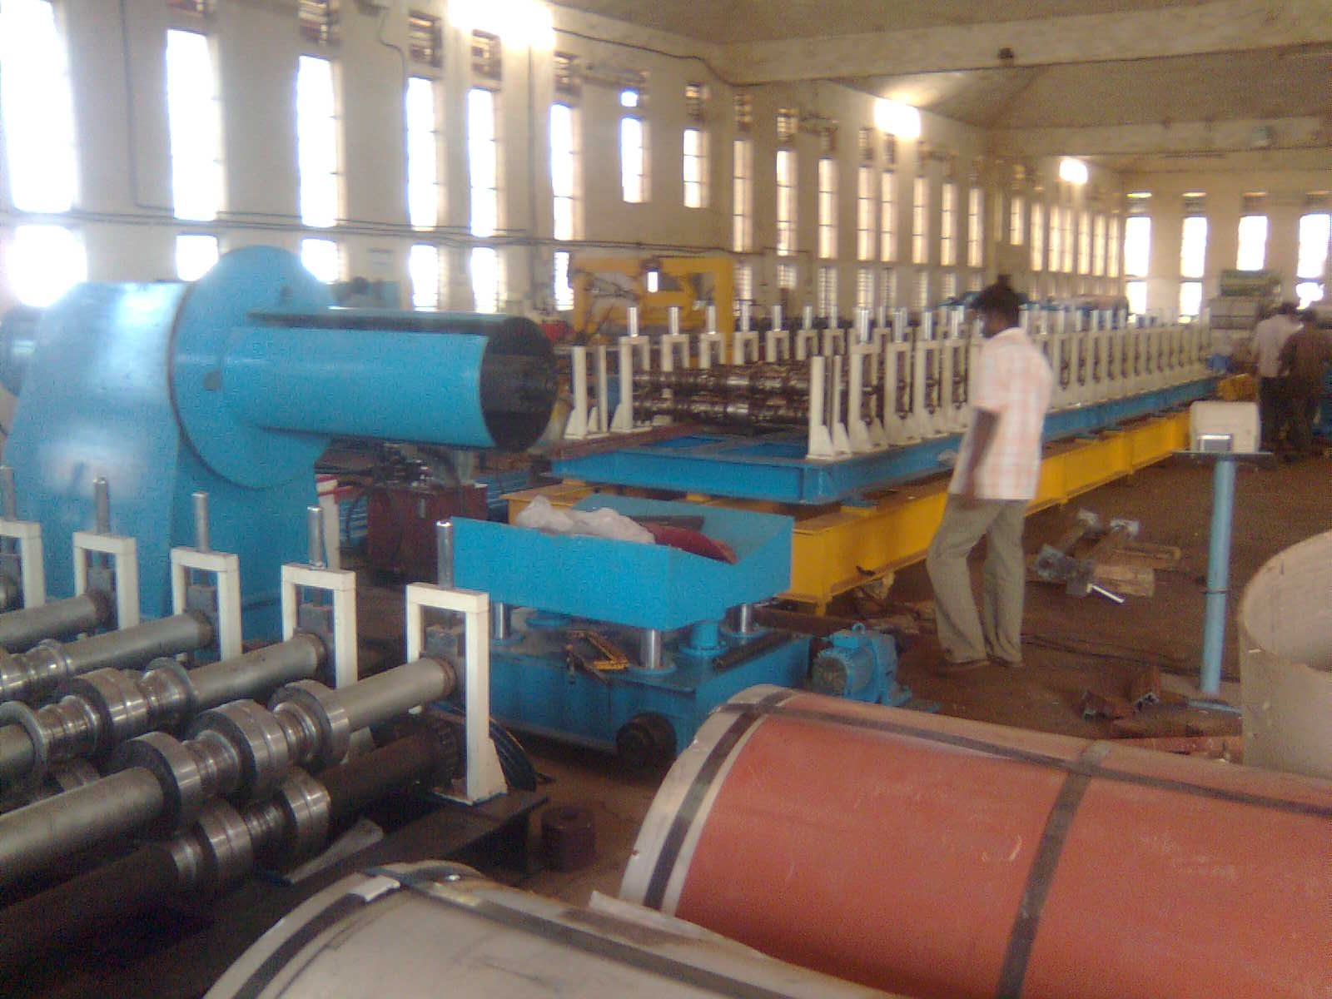

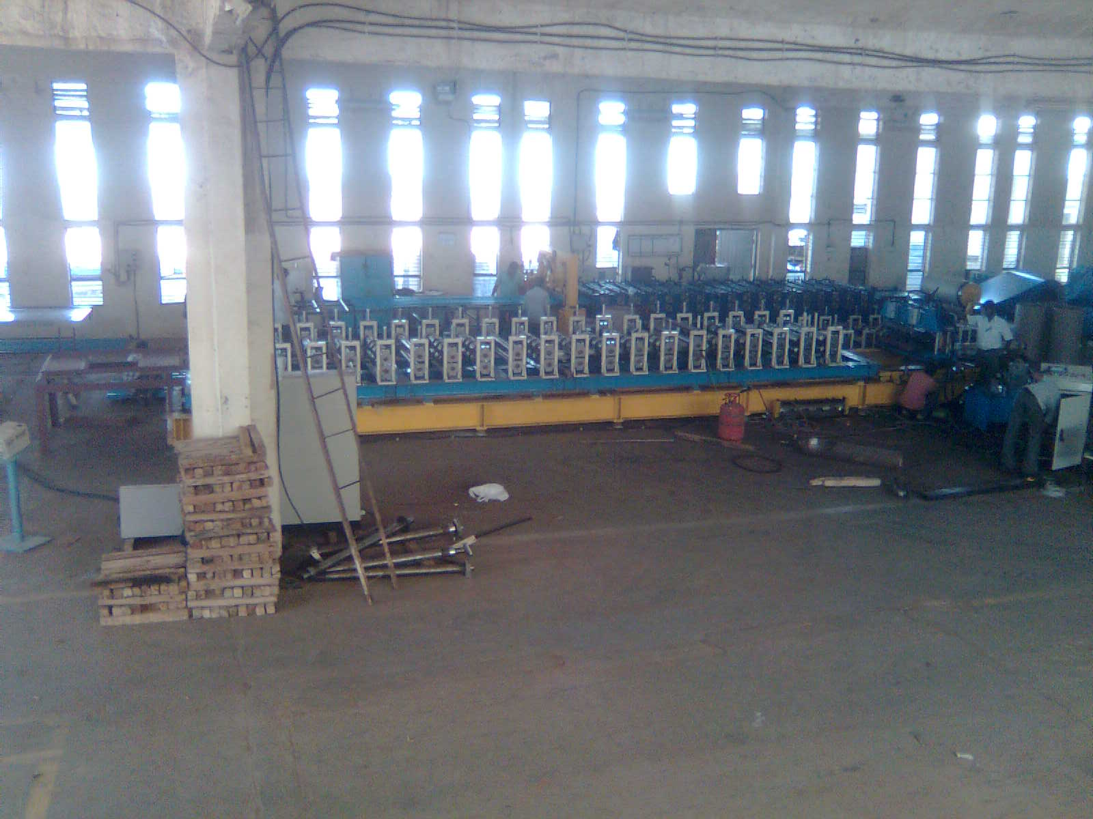

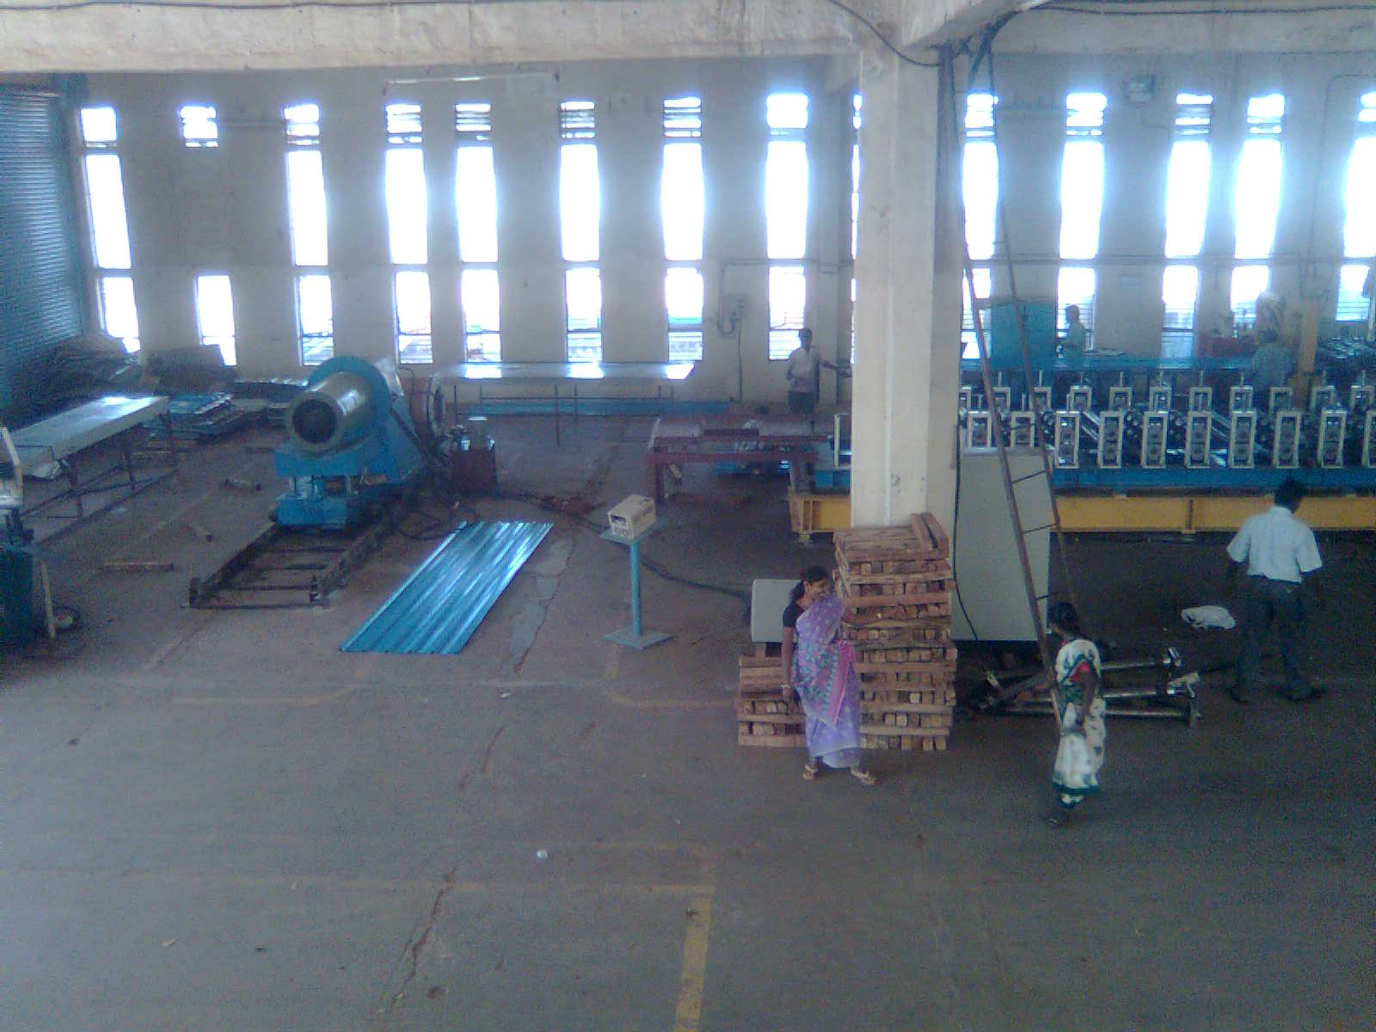

Description of the equipment

Roll Forming Machine

Main Base

The main base is MS fabricated structure and adequately ribbed to minimize the distortion. It is accurately machined on top and bottom surfaces the threaded holes are made on the bed for positioning the stands.

Entry Guide

The entry side of the machine will be equipped with guide table and the guide wheels bar which will be responsible for centering the leading ends of the strip into the first pass.

Mill stands

The stands are mounted on the bed of the machine the line alignment can be easily done due to guide ways arranged on the bed of the machine. Each forming head consists of a fixed housing and sliding type out board housing. The mill stands will be arranged to locate shafts mounted on anti-friction bearings. For the top shafts the bearings are housed in the cartridge type bearing blocks. The bottom shaft bearings are located in the bored machined in the housings. The bottom arbors are fixed in position whereas the top arbors along with cartridge blocks could be raised or lowered in vertical guides machined in housings.

Roll shafts

The roll shafts will be manufactured from quality steel and will be keyed to locate tooling.

Drive

The drive to the roll former will be by means of a gear box system. The main drive will be provided by means of 7.5 HP motor. The speed of the roll former is veariable.

Delivery runout table

The delivery runout table is with fourteen meters length.

Cutoff unit

The cutoff unit with hydraulic press along with cutting die set will be placed in the machine delivery side.

GENERAL TERMS & CONDITIONS:

- Price quoted per unit ex-work. Hyderabad.
- Following charges are additional to your account.
- Freight Charge : As actual to be borne by you.
- Sales Tax : 18% Extra as applicable
- Packing charge : As actual to be borne by you.
- Insurance : As actual to be borne by you.
- Payment : 50% advance along with order,
: balance 50% after installation and before delivery
- Delivery : within 8 weeks from date of advance received
- Validity : One month from the date of submission.
- Inspection : Inspection at our works prior to dispatch.
- Warranty : The machine is warranted for a period of 12 months from the date of dispatch against any manufacturing defects/ faulty material or bad workmanship of any part or component but not against any kind of abnormal or improper use of machine. Defective part or component will be replaced or repaired free of cost. Electrical components are outside the scope of this warranty.
- Commissioning : Erection & commissioning done by you, but required technical support & guidance provide by us at additional cost.

NOTE:
- Oil is not in scope of our supply.
- Raw material for trial is to be arranged by you at your cost.

We are sure you will find our offer in line with your requirements. Should you require any further clarification please contact T. Sivaramakrishna, 9246221106. Email: md@technomachinetools.in WhatsApp No: 9849207176

Thanking you and assuring you of our best services.

For TECHNO MACHINE TOOLS

( T. SIVARAMAKRISHNA)

TECHNO MACHINE TOOLS

Survey no:126/A/1, DOOR NO: 4-132-9/A/2, Gandimaisamma X Road,

Medchal Malkajgeri, Hyderabad-500044.

(Machine tool manufacturers)

T.SIVARAMAKRISHNA
ME., MBA.
--------------------------------------------------------------------------------------------------------------------------------------
TMT/ Ravinder Naik/S0380/2025 12-07-2025

To,
Ravinder Naik,
Mobile: +91 98582 36666

Dear sirs,

Sub: - QUOTATION FOR SLITTING HEAD

Thank you very much for your inquiry regarding your requirement of Slitting Head mainly for MS / GI / Pre- coated Sheets. We are glade to inform you that we would be in a position to supply you the required equipment. Given below are the required specifications and description of the machine and our terms and conditions.

TECHNICAL SPECIFICATIONS:

Maximum sheet width that can be slitted : 1250 MM

Maximum sheet thickness in MS that can be slitted : 0.6 MM

Minimum sheet thickness in MS that can be slitted : 0.3 MM

Speed of the machine : 0-9.0 meters/min

Number of cuts maximum : 16 nos

DESCRIPTION OF THE EQUIPMENTS

SLITTER HEAD

The slitter Head consists of 5 HP AC motor along with AC Drive, gearbox system along with spindle attachment. The arbors vertical distance can be adjusted by means of spur gears train and reduction gearbox attachment. The operator side stand movement is by means of screw with handle. The de-burring unit is attached after the cutters which is drive free and the load can be given with manual screw adjustment.

ENTRY GUIDE

The entry side of slitter head is by means of guide table; guide blocks along with guide rolls. Which will be responsible for centering the leading ends of the sheet in to the first pass.

PRICES

Slitting head along with, Leveler Unit, Entry guide, shearing unit, slitter head, along with power pack and other electrical connections is RS 3,80,000=00 ( Rupees Three Lacks Eighty Thousand Only)

GENERAL TERMS & CONDITIONS:

1. Price quoted per unit ex-work. Hyderabad.
- Following charges are additional to your account.
- Freight Charge : As actual to be borne by you.
- Tax : 18% Extra as applicable
- Packing charge : As actual to be borne by you.
- Insurance : As actual to be borne by you.
- Payment : 75% advance along with order balance before delivery but after inspection at our works.
- Delivery : Within 2 months from date of advance received
- Validity : One month from the date of submission.
- Inspection : Inspection at our works prior to dispatch.
- Warranty : The machine is warranted for a period of 12 months from the date of dispatch against any manufacturing defects/ faulty material or bad workmanship of any part or component but not against any kind of abnormal or improper use of machine. Defective part or component will be replaced or repaired free of cost. Electrical components are outside the scope of this warranty.
- Commissioning : Erection & commissioning done by you, but required technical support & guidance provide by us at additional cost.

NOTE:
- Oil is not in scope of our supply.
- Raw material for trial is to be arranged by you at your cost.

We are sure you will find our offer in line with your requirements. Should you require any further clarification please contact 9246221106

Thanking you and assuring you of our best services

For TECHNO MACHINE TOOLS

(T.SIVARAMAKRISHNA)

TECHNO MACHINE TOOLS

Survey no:126/A/1, DOOR NO: 4-132-9/A/2, Gandimaisamma X Road,

Medchal Malkajgeri, Hyderabad-500044.

(Machine tool manufacturers)

T.SIVARAMAKRISHNA
ME., MBA.
--------------------------------------------------------------------------------------------------------------------------------------
TMT/ Ravinder Naik/S0380/2025 12-07-2025

To,
Ravinder Naik,
Mobile: +91 98582 36666

DEAR SIR,

Sub: - SUPPLY OF Edge Crimping / Arch Crimping MACHINE

Thank you very much for your enquiry regarding your requirement of Crimping machine mainly for color coated Sections. We are glad to inform you that we would be in a position to supply you the required equipment. Given below are the required specifications and description of the machine and our terms and conditions.

Prices

The cost of Crimping machine along with Power Pack 5 HP and crimping Tool suitable to your profile is Rs 6,50,000=00 (Six Lakhs Fifty Thousand Only)

Technical Specifications:

- Product’s feature:
This crimping roll forming machine is used to curve panel for formed sheet from ZYYX30-200-1000 / suitable profile.

- Main technical parameters

1) Max. Width of Formed steel sheet: Suitable Profile
2) Material thickness : 0.3-0.8mm color coated steel sheet.
3) Main motor power : 2.2kw (Depend on final design)
4) Hydraulic station power : 3.75 kw (Depend on final design)
5) Min. bending radium : 300mm
6) Crimping length: min. 25mm, max. Crimping length - no limit.
7) Crimping strokes : 12-15 strokes /minute
8) Bending : By hydraulic
9) Control : PLC control
10) Curving roller material : Cr12 mould steel.
11) Size of machine : 2500 mm X 1100 mm X 1600 mm (Ht)
GENERAL TERMS & CONDITIONS:

- Price quoted per unit ex-work. Hyderabad.
- Following charges are additional to your account.
- Freight Charge : As actual to be borne by you.
- Sales Tax : 18% Extra as applicable
- Packing charge : As actual to be borne by you.
- Insurance : As actual to be borne by you.
- Payment : 50% advance along with order balance before delivery but after inspection at our works.
- Delivery : with 50% advance with in 3 months.
- Validity : One month from the date of submission.
- Inspection : Inspection at our works prior to dispatch.
- Warranty : The machine is warranted for a period of 12 months from the date of dispatch against any manufacturing defects/faulty material or bad workmanship of any part or component but not against any kind of abnormal or improper use of machine. Defective part or component will be replaced or repaired free of cost. Electrical components are outside the scope of this warranty.
- Commissioning : Erection & commissioning done by you, but required technical support & guidance provide by us at additional cost.

NOTE:
- Oil is not in scope of our supply.
- Raw material for trial is to be arranged by you at your cost.

We are sure you will find our offer in line with your requirements. Should you require any further clarification please contact sivaramakrishna 9246221106.Email: md@technomachinetools.in
Thanking you and assuring you of our best services.



For Techno Machine Tools

T. SIVARAMAKRISHNA

Our Bank details

TECHNO MACHINE TOOLS
A/C NO: 11534015002032
IFSC CODE: PUNB0115310
BRANCH: BALANAGAR, HYDERABAD

GST NO: 36AELPT9784K1ZC

